Klorsept & Klorkleen
- Sodium Dichloro-isocyanurate - known as NaDCC
- NaDCC is an organic chlorine donor
- NaDCC is not a hypochlorite
- it has unique properties
(Hypochlorites are the salts of hypochlorous acid. Such as sodium hypochlorite (chlorine bleach and calcium hypochlorite.)
- It is a fast acting, powerful biocide
- Tablet size from 50mg finished weight to 19g.
- Mainly 50:50 NaDCC: Effervescent Base.
- Packaged in aluminium foil strips or tubs
Validation Results
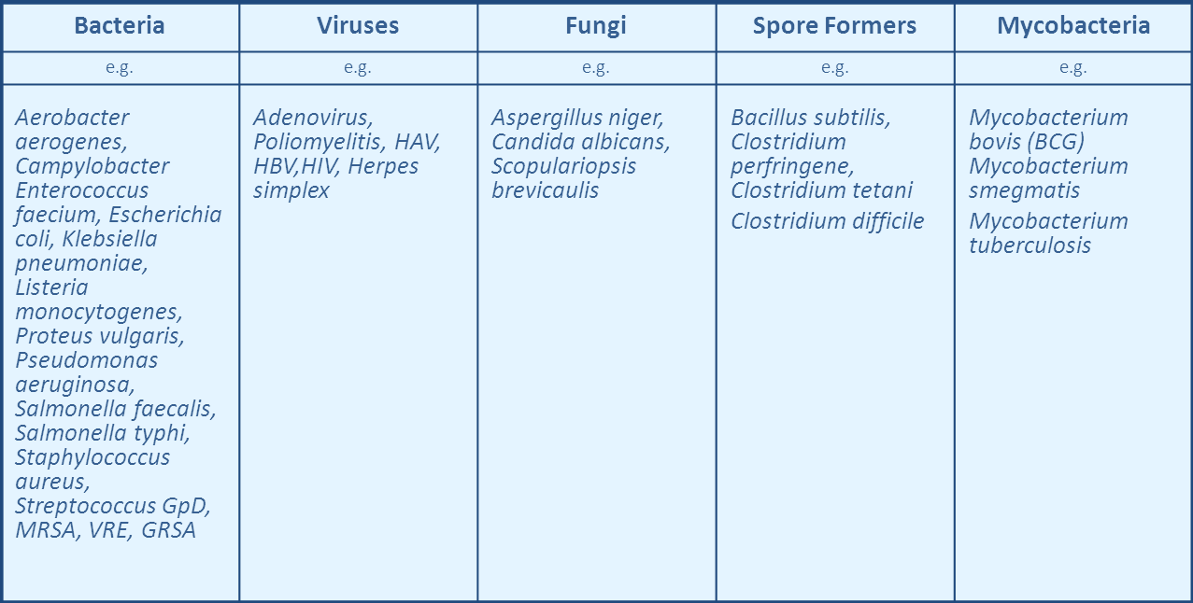

The Chemistry of Sodium Dichloroisocyanurate / NaDCC

……NaDCC creates an acidic solution with >90% active chlorine
- Dissolve in water & releases hypochlorous acid (HOCl) and monosodiumcyanurate (a non-toxic biodegradable compound).
- HOCl is the biocidal agent
- HOCl similar structure to water (HOH) therefore less resistance to penetrating the cell wall

Hypochlorites 10% active chlorine: pH 9.5 (av)

NaDCC / TCCA >90% active chlorine: pH 5.5 – 6.5

HOCL - available Chlorine

NaDCC : the Residual Killing Power
NaDCC dissolves in water to release HOCl : measured as available chlorine
- The ratio of “free” and “combined” available chlorine always remains at 50:50
- As “free available” chlorine is used up (e.g. organic matter, microorganisms, etc) the balance is disturbed
- Part of the “combined” available chlorine is then “freed” to restore the 50:50 ratio
- This happens until all the “combined” available chlorine is used up
- This is unique to NaDCC
HOCL - available Chlorine
50% 50%
Free Combined
In Equilibrium
HOCL: 100% available chlorine
50% of the “total” available chlorine is actually present as “free” available chlorine
The remainder is “combined” in the form of mono – or dichloroisocyanurate

Undissociated
Dissociated
HOCl
H⁺ + OCl ⁻

